The New Jersey Boxing Hall of Fame Newsletter
Volume 17 Issue 9 E-Mail Address: hhascup@yahoo.com September 2012 Next meeting date - PRESIDENT - henry HASCUP 59 kipp ave, lodi, n.j. 07644 (1-973-471-2458)

Thursday,
September 20th
* The next meeting for the New Jersey Boxing Hall of Fame will be on Thursday, September 20th, at the Faith Reformed Church located at 95 Washington St. in Lodi, N.J. which is on the corner of Washington and Prospect St., starting at 8:00 P.M.

* We again will be showing Old Time Boxing films starting at 6 P.M.

*We will have the 2011 AD journals for those who gave out ADS and we will also be selling the extra journals for only $2.00 each, plus postage.

* As the President of the New Jersey Boxing Hall of Fame I am proud to name our 2012 Inductees:
The 14-member class includes ring announcer Joe Antonacci, judge Lynne Carter, junior lightweight/lightweight Sal Cenicola, heavyweight Lou Esa, junior welterweight Ricky Meyers, bantamweight Don Nisivoccia, junior middleweight/middleweight Pat Prisco, judge John Riley, junior welterweight & welterweight Ivan Robinson, the Originator of the Modern Boxing Belt Ardash Sahaghian, lightweight Tony Santana and light heavyweight James Scott. Referee Mark Conn and judge Robert Grasso will be inducted posthumously.
The Class of 2012 will be enshrined at the NJBHOF’s 43rd annual dinner and induction ceremonies on Nov. 8 at The Venetian in Garfield, N.J. For tickets ($80) to the event, contact President Henry Hascup at 973-471-2458 or hhascup@yahoo.com .
Also the NJBHOF will be honoring our Senior Amateur Boxer (Leroy Davila), Junior Olympic Amateur Boxer (Ash Shakur Stevenson) & Professional Boxer of the Year (Tomasz Adamek) as well as the Amateur Official (Pete Quinones), Coach of the Year (Dan Doyle), and our “2012 Man of the Year,” (John Quinn). PLUS Essay Winner Awards!!!! WE NEED THE BIO’S & PICTURES ON ALL THE HONOREES ASAP. Ring Notes:
*Ring # 8, of New York will have their next meeting on Tuesday, September 18th at the Waterfront Crab House 2-03 Borden Ave. Long Island City (718) 729-4862, @ 7pm. Contact President Bob Duffy at 516-313-2304.
*Ring # 25 has there meeting at the Senior Citizen Hall in Kearny. Contact Cosmo Liaci at 201-240-0889
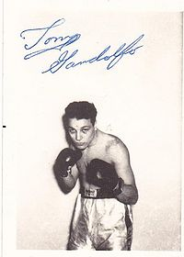1949 New York Golden Glove Champion and Pro fighter, Tony Gandolfo passed away.
Tony was a long time member of the NJBHOF, Ring 25 and Ring 8 (since the mid-1950's). Tony beat in Ralph Tiger Jones when both of them were the Amateurs, and had a Professional career record of 21-4-2 with 11 KO's and was inducted into the New Jersey Boxing Hall of Fame in 2003.
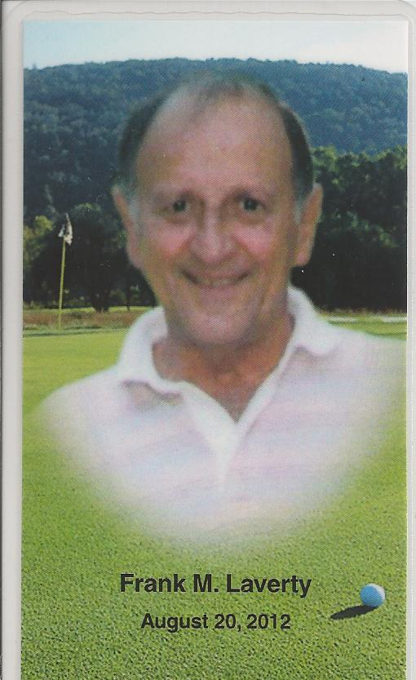

Also, longtime member of the NJBHOF Frank Laverty passed away last month. Frank was the uncle of Irish Pat, Dennis and Terry Murphy, and was the one that got Pat started in boxing.

*** WE NEED YOUR HELP! ***
PLEASE try to put in some kind of AD, even if it’s just a quarter of a page, every little bit helps. You can even put in an AD with another person or two, and split the cost. If you were inducted into the Hall of Fame, you can use your Hall of Fame page as your AD. If you still can’t do that, maybe you can get a few boosters at a $1.00 each. This is our only fundraiser of the year and we need as much help as possible.
Keep Punching, President, Henry Hascup

